**Supporting Documentation for World Cup 2023 Analysis**

**Selection Criteria for each category of players:**

Top order batsmen

|  |  |
| --- | --- |
| **Statistic** | **Criteria** |
| Batting Average | >45 |
| Batting Position | <4 |
| Strike Rate | >90 |
| Total games Batted | >5 |
| Total Runs | >450 |

Middle order batsmen

|  |  |
| --- | --- |
| **Statistic** | **Criteria** |
| Batting Average | >50 |
| Batting Position | >3 & <7 |
| Strike Rate | >90 |
| Total games Batted | >5 |
| Total Runs | >=400 |

Lower middle order

|  |  |
| --- | --- |
| **Statistic** | **Criteria** |
| Bowling Average | <30 |
| Batting Position | >6 and <9 |
| Wickets | >10 |
| Bowling Strike rate | <35 |

Tailenders

|  |  |
| --- | --- |
| **Statistic** | **Criteria** |
| Bowling Average | <=25 |
| Batting Position | >8 |
| Wickets | >15 |
| Bowling Strike rate | <30 |

*Parameter definitions  
Batting Average: Average runs scored by a player in all the matches combined in the tournament.

Batting Strike rate: Runs scored per 100 balls  
  
Bowling Strike rate: Average number of balls bowled by the bowler to get wicket.

**Some interesting findings from the analysis:   
Relation between balls faced and strike rate**

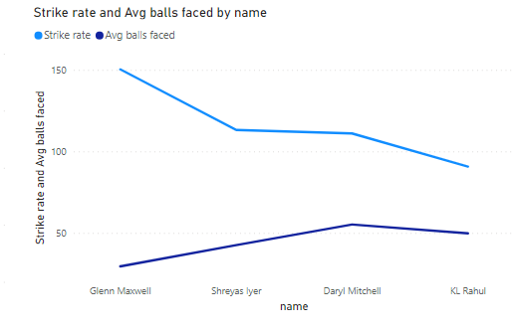

The above two plots of the variation in Strike rate and average balls faced shows an inverse relationship. That is, when a batsman plays with a high strike rate, he ends up getting out faster as compared to the batsmen playing at a lower strike rate.

Explanation: When batsman try to increase their strike rate, they tend to take more risks. When they do this by playing more aerial shots and coming out of the crease, there is an increased chance of misjudging the ball, leading to getting out through various methods such as getting caught out.

Relation between bowling strike rate and economy

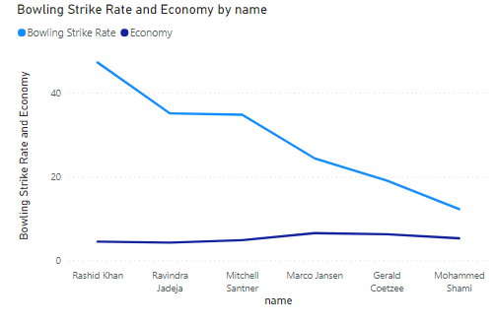

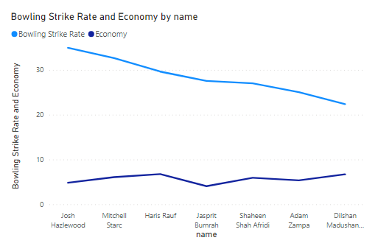

Similarly, observing the two plots given above, we can see an inverse relation between bowling strike rate and economy. Economy is the number of runs conceded by a bowler in an over (i.e. 6 balls). When the economy is decreasing, it means the batter is scoring less runs per over. It means, it is more likely that the bowler is getting respect, and the batsman is playing either defensively or leaving the ball. It decreases the chance of the batsman getting out. And hence, the average number of balls bowled by the bowler for getting each wicket increases.